FOR IMMEDIATE RELEASE
Press Release

For more information, please contact:
Brian Sivasamboo | brian@madhat.asia | +6019-609 9518
Priyatasha Prem | priyatasha@madhat.asia | +6012-620 0664

Going Dry on Alcohol Made Easier
with Heineken® 0.0 Dry March
Now you can claim your Heineken® 0.0 Dry Pack and
restart 2021 to enjoy a guilt-free March without losing the fun!

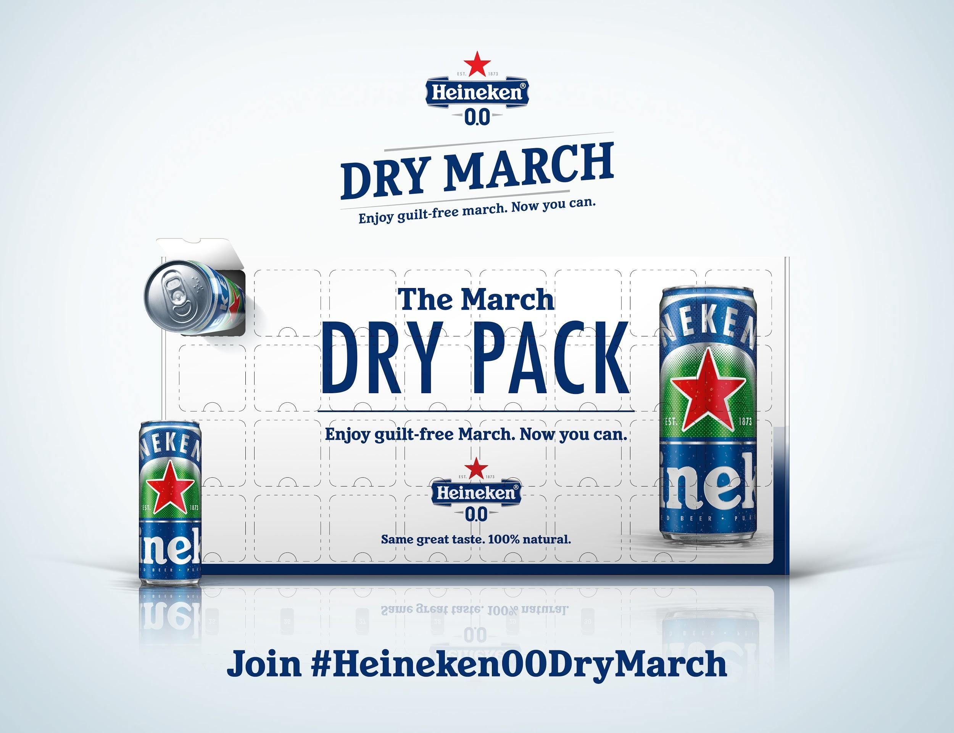

KUALA LUMPUR, 4 MARCH 2021 – Want to get into your ‘New Year New Me’ goals after overindulging in food and drinks during the festive season? With the New Year and Chinese New Year holidays having recently ended, Heineken® 0.0 wants to help you take a step back and refresh with the Heineken® 0.0 Dry March campaign. Taking inspiration from the popular global trend of Dry January where consumers give up alcohol for a month, Heineken® 0.0 aims to help Malaysians adopt a balanced lifestyle by having their own Dry March. So to kick-start your dry month, Heineken® 0.0 is giving out special 31-day Heineken® 0.0 Dry March Packs. #NowYouCan claim your free Heineken® 0.0 Dry March Pack and start your guilt-free March.

Going dry on alcohol does not mean zero fun! To keep you motivated and to achieve a more balanced lifestyle this March, Heineken® 0.0 is partnering with local fitness instructors and a celebrity chef to curate a series of virtual activities to enjoy with a can of ice cold Heineken® 0.0. The series kicks off on 7th March with star fitness instructor and active lifestyle enthusiast Teo Yi Ping (@yipingteo), as she brings a high-intensity, full-body strength class session to your living rooms. Next, get ready to groove to hip hop, R&B, disco, soul and afro tunes, as you learn how to dance at parties with one of Malaysia’s top dance and fitness talents, Maybelline Wong (@definitelymayb_), on 13th March.

Starving from all the workouts? Fear not, as Heineken® 0.0 brings celebrity Chef Darren Chin (@darren_chin168) of the award-winning DC Restaurant, to your screens. So grab your aprons and treat yourself to a balanced meal that pairs well with Heineken® 0.0 to enjoy guilt-free March on the 20th. To wrap up the virtual sessions, fitness instructor Alex Chee (@alex_cyk) brings a HIIT workout session on 27th March that promises to get you breaking a sweat.

“Many of us have overindulged in food and drinks because of the holidays and festivities since December. To help our consumers to get back on track, we’re launching the Heineken® 0.0 Dry March campaign – because now you can still have fun while working towards a balanced lifestyle. We welcome everyone to join all the action from the comfort of their homes with an ice cold Heineken® 0.0” said Pablo Chabot, Marketing Director of Heineken Malaysia Berhad.

Get free Heineken® 0.0 today by participating in the month-long, guilt-free activities in the #Heineken00DryMarch 31Days Calendar on www.heineken00drymarch.com. Sign up today and join in the fun by submitting your entries on Instagram with the hashtag #Heineken00DryMarch and tagging @HeinekenMY. The all-new Heineken® 0.0 can is also available in Peninsular Malaysia, in selected hyper/supermarkets and convenience stores.

Heineken® 0.0 and all promotions are for non-Muslims aged 21 and above only. For more information and updates, log on to the Heineken® 0.0 Dry March website at www.heineken00drymarch.com or follow Heineken® on Instagram (@HeinekenMY) and Facebook (https://www.facebook.com/HeinekenMYS/).

- END -
Note to Editors
Heineken Malaysia Berhad
HEINEKEN Malaysia with its portfolio of iconic international brands is the leading brewer in the country. The Company brews, markets and distributes:
- The World’s No. 1 international premium beer Heineken®
- The great taste of Heineken® with 100% natural ingredients Heineken® 0.0
- The World-acclaimed iconic Asian beer Tiger Beer
- The crystal-cold filtered beer Tiger Crystal
- The World’s No. 1 stout Guinness
- The World’s No. 1 cider Strongbow Apple Ciders
- The New Zealand inspired cider Apple Fox Cider
- The all-time local favourite Anchor Smooth
- The premium Irish ale Kilkenny
- The real shandy Anglia
HEINEKEN Malaysia also produces the wholesome, premium quality non-alcoholic Malta. HEINEKEN Malaysia’s brand portfolio also includes the No. 1 German wheat beer Paulaner and Japan’s No. 1 100% malt beer Kirin Ichiban. The Company continues to lead the responsible drinking agenda through its Drink Sensibly campaign.
Listed on the Main Market of Bursa Malaysia, HEINEKEN Malaysia’s principal shareholder is GAPL Pte Ltd based in Singapore. GAPL Pte Ltd is 100% owned by Heineken N.V.
For more information please visit: www.heinekenmalaysia.com

